HOW TO MAKE A DANCE BUN FOR SHORT HAIR
(THIS WILL WORK FOR HAIR EAR TO SHOULDER LENGTH)
TOOLS
HAIR BRUSH COMB GEL HAIR SPRAY
HEAVY ELASTIC BAND BOBBY PINS HAIR PINS (2” OR LONGER) HAIR NET

USE NON-SCENTED AROSOL HAIR SPRAY LIBERALLY. 2” OR LONGER HAIR PINS ARE AVAILABLE AT AMAZON IN BLACK OR BLOND. EVERYTHING ELSE IS AVAILABLE AT YOUR LOCAL DRUG STORE.

TRY TO GET BUNS AS FLAT AS POSSIBLE. ABSOLUTELY NO BANGS

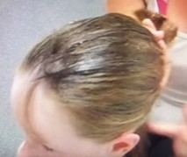
STEP 1: APPLY GEL ALL AROUND THE HAIR LINE. USING HANDS WIPE HAIR BACK TOWARD CROWN AND GATHER INTO PONYTAIL.

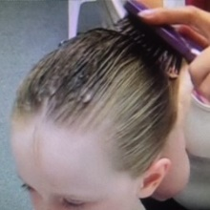
STEP 2: USE BRUSH TO SMOOTH HAIR INTO PONY TAIL. DON’T WORRY IF SOME HAIR IS TOO SHORT FOR THE PONYTAIL AT THIS POINT. JUST GET AS MUCH HAIR AS POSSIBLE IN THE PONYTAIL.

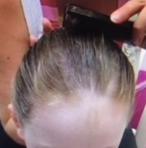
STEP 3: USE COMB TO FURTHER SMOOTH HAIR INTO PONYTAIL, WORKING AROUND THE HEAD AND GATHERING HAIR INTO YOUR OTHER HAND.

STEP 4: APPLY ELASTIC BAND TO GATHERED HAIR.

STEP 5: FOR HAIR THAT DOESN’T REACH THE PONY SPRAY WITH HAIR SPRAY
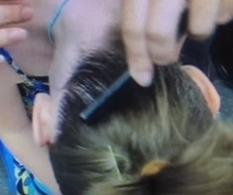
COMB TOWARD THE PONYTAIL
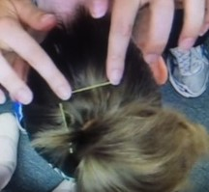
AND BOBBY PIN.

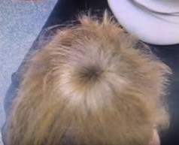
STEP 6: TO MAKE “BUN” DIVIDE HAIR EVENLY AROUND PONYTAIL, SPRAY WITH HAIR SPRAY
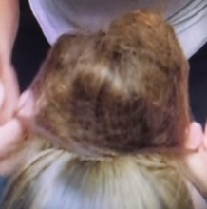
TAKE HAIR NET AND TWIST TO DOUBLE (LIKE YOU WOULD A RUBBERBAND), PLACE OVER DIVIDED HAIR TUCKING ENDS UP INTO HAIR NET.
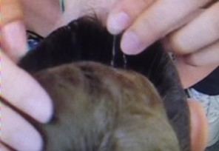
USE HAIR PINS AROUND THE BUN TO SECURE

HOW TO MAKE A DANCE BUN FOR LONG HAIR
TOOLS
HAIR BRUSH COMB GEL HAIR SPRAY
HEAVY ELASTIC BAND BOBBY PINS HAIR PINS (2” OR LONGER) HAIR NET

USE NON-SCENTED AROSOL HAIR SPRAY LIBERALLY. 2” OR LONGER HAIR PINS ARE AVAILABLE AT AMAZON IN BLACK OR BLOND. EVERYTHING ELSE IS AVAILABLE AT YOUR LOCAL DRUG STORE.

TRY TO GET BUNS AS FLAT AS POSSIBLE. ABSOLUTELY NO BANGS
STEP 1: APPLY GEL ALL AROUND THE HAIR LINE. USING HANDS WIPE HAIR BACK TOWARD CROWN AND GATHER INTO PONYTAIL.

STEP 2: USE BRUSH TO SMOOTH HAIR INTO PONY TAIL. DON’T WORRY IF SOME HAIR IS TOO SHORT FOR THE PONYTAIL AT THIS POINT. JUST GET AS MUCH HAIR AS POSSIBLE IN THE PONYTAIL.

STEP 3: USE COMB TO FURTHER SMOOTH HAIR INTO PONYTAIL, WORKING AROUND THE HEAD AND GATHERING HAIR INTO YOUR OTHER HAND.

STEP 4: APPLY ELASTIC BAND TO GATHERED HAIR

STEP 5: SPRAY AROUND FRONT AND BACK OF HEAD. COMB HAIR TOWARD PONYTAIL. BOBBY PIN ANY STRAY HAIR.

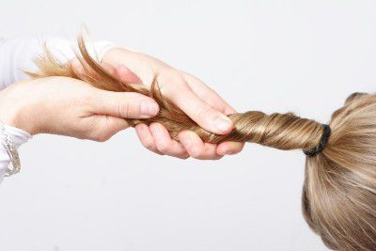
STEP 6: TO MAKE BUN. TWIST THE ENTIRE PONYTAIL INTO A TIGHT ROPE.

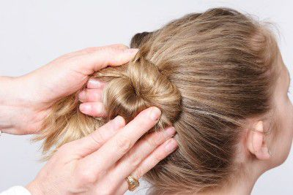
STEP 7: WRAP YOUR HAIR ROPE TIGHTLY AROUND THE BASE OF THE PONYTAIL. PIN WITH A FEW HAIR PINS. APPLY HAIR NET TWISTED AS MANY TIMES AS WILL FIT ON YOUR BUN. SECURE WITH AS MANY HAIR PINS AS NECESSARY. SPRAY WITH HAIR SPRAY.

